Latihan TM06 MBD
Nama: Maulana Ikhsan
NIM: 5025241163
No.1
Sintaks:
CREATE VIEW HighSalaryCustomers AS
SELECT NAME, SALARY, AGE
FROM customers
WHERE SALARY > 2000.00;

Hasil:
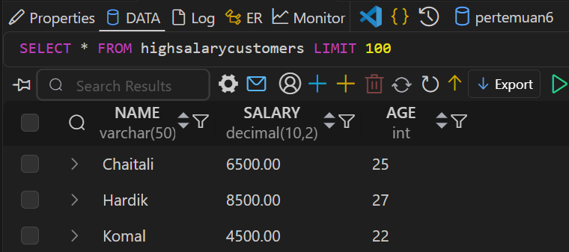

No.2
Sintaks:
CREATE VIEW SalaryPercentageView AS
SELECT
NAME,
(SALARY / (SELECT SUM(SALARY) FROM customers)) * 100 AS Percentage
FROM customers
ORDER BY Percentage DESC;

Hasil:
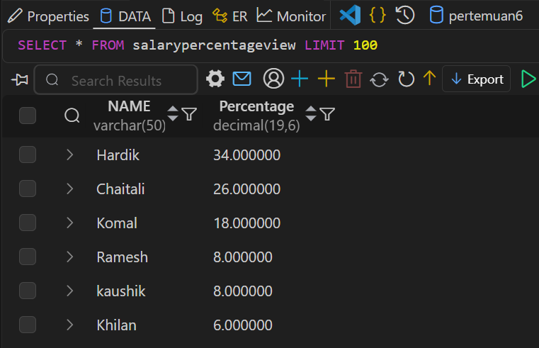

No.3
Sintaks:
CREATE TABLE salary_log (
IDLog INT AUTO_INCREMENT PRIMARY KEY,
date TIMESTAMP DEFAULT CURRENT_TIMESTAMP,
previous_salary DECIMAL(10,2),
next_salary DECIMAL(10,2)
);

Hasil:
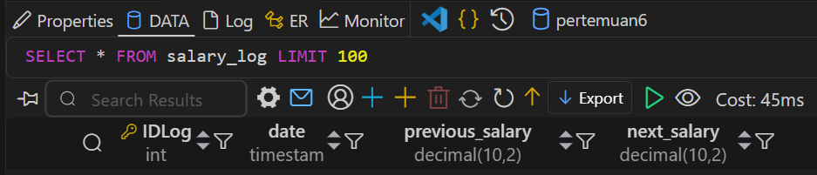

No.4
Sintaks:
DELIMITER //
CREATE TRIGGER AfterSalaryUpdate
AFTER UPDATE ON customers
FOR EACH ROW
BEGIN
IF OLD.SALARY <> NEW.SALARY THEN
INSERT INTO salary_log (date, previous_salary, next_salary)
VALUES (NOW(), OLD.SALARY, NEW.SALARY);
END IF;
END; //
DELIMITER ;

Hasil:
